Sari-Sari Store Inventory System

Group Members:
Jann Mhareoul Abancio 2024-4579-A
Elizabeth Satumbaga 2023-6881-A
Darleen Joy Esteves 2024-4609-A
Raezzel Lou Fabila 2024-4609-A

Course, Year & Section:
BS INFO TECH 2C

Mr. Kenny Saylo
Course Instructor

June 15, 2026

Final Project | Section 2 – Systen Overview | DBSYS 1

SARI-SARI STORE INVENTORY SYSTEM
The Sari-Sari Store Inventory System is a database-driven application designed to help sari-sari store owners manage their daily inventory operations more efficiently. In many small stores, inventory records are often written manually, which can lead to errors, misplaced information, and difficulties in monitoring stock levels. This system was developed to provide a more organised and reliable way of handling inventory data.
The system allows users to record product information, monitor available stocks, manage supplier details, and track stock movements such as restocking and inventory adjustments. By storing all inventory-related information in a centralized database, users can easily access accurate and up-to-date records whenever needed.
This system is intended for sari-sari store owners, managers, and staff who need a convenient tool for managing inventory. It helps address common challenges such as stock shortages, overstocking, inaccurate record-keeping, and delays in restocking products. Through automation, the system reduces manual work, minimizes human errors, and improves overall efficiency in inventory management.
Overall, the Sari-Sari Store Inventory System serves as a practical solution that helps store owners maintain accurate inventory records, make informed business decisions, and ensure the continuous availability of products for customers.

Final Project | Section 3 - ERD (Entity-Relationship Diagram) | DBSYS 1

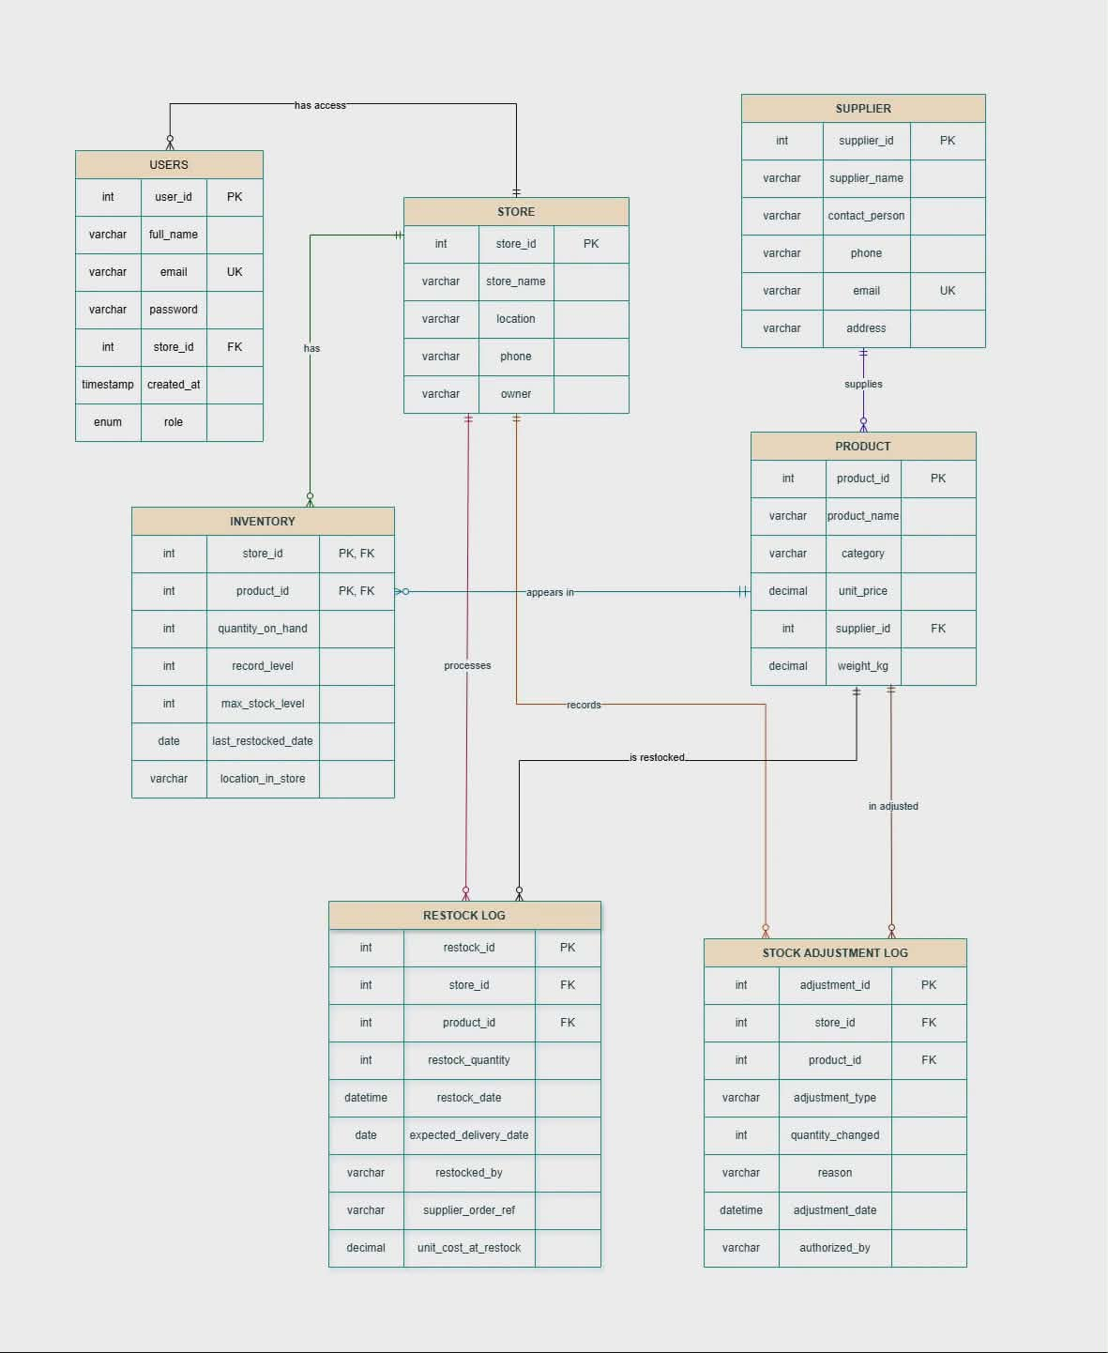

Final Project | Section 4 – Data Dictionary | DBSYS 1

USERS
Field Name | Data Type | Constraints | Description
User_id | INT | PK, NOT NULL | Unique identifier for every system user (admin/staff)
Full_name | VARCHAR | NOT NULL | Full name of the user
email | VARCHAR | UK, NOT NULL | Login username & official contract address – no duplicates
password | VARCHAR | NOT NULL | Hashed login credential – never store plain text
Store_id | INT | FK -> STORE | Links user to the store/location they are assigned to
Created_at | TIMESTAMP | DEFAULT | Exact account creation time
role | ENUM | NOT NULL | Access level: e.g. ‘Admin’, ‘Manager’, ‘Staff’

STORE
Field Name | Data Type | Constraints | Description
Store_id | INT | PK, AUTO_INCREMENT | Unique branch/location ID
Store_name | VARCHAR | NOT NULL | Official business name of the brance
location | VARCHAR | NOT NULL | Full address or geographic number
phone | VARCHAR | NOT NULL | Landline or mobile contact number
owner | VARCHAR | NOT NULL | Name/identifier of the store owner or lead manager

SUPPLIER
Field Name | Data Type | Constraints | Description
Supplier_id | INT | PK, AUTO_INCREMENT | Unique vendor record number
Supplier_name | VARCHAR | NOT NULL | Company/brand name of the supplier
Contact_person | VARCHAR | NOT NULL | Name or representative handling orders
phone | VARCHAR | NOT NULL | Contact number of supplier
email | VARCHAR | UK, NOT NULL | Official business email – unique per supplier
address | VARCHAR | NOT NULL | Physical address of supplier

PRODUCT
Field Name | Data Type | Constraints | Description
Product_id | INT | PK, AUTO_INCREMENT | Unique SKU/code for every stocked/sold item
Product_name | VARCHAR | NOT NULL | Descriptive display name of the item
category | VARCHAR | NOT NULL | Product group (Drinks, Snacks, Toiletries)
Unit_price | DECIMAL | NOT NULL, >=0 | Standard selling price per single unit
Supplier_id | INT | FK, SUPPLIER (supplier_id) | References for the main supplier for this product
Weight_kg | DECIMAL | NOT NULL | Item weight in kilograms – for shipping & storage

INVENTORY
Field Name | Data Type | Constraints | Description
Inventory_id | INT | PK, AUTO_INCREMENT | Unique inventory id
Store_id | INT | FK, STORE (store_id) | Identifies which branch holds the stock
Product_id | INT | FK, PRODUCT (product_id) | Identifies which product is tracked
Quantity_on_hand | INT | NOT NULL, DEFAULT 0, >=0 | Current available stock count at this location
Record_level | INT | NOT NULL | Minimum threshold before re-order alert
Max_stock_level | INT | NOT NULL | Maximum allowed quantity for storage capacity
Last_restocked_date | DATE | NULL | Date the last replenishment was received
Location_in_store | VARCHAR | NOT NULL | Shelf, aisle, bin or rack code foe quick picking

RESTOCK_LOG
Field Name | Data Type | Constraints | Description
Restock_id | INT | PK, AUTO_INCREMENT | Unique receipt/ID for each restock transaction
Store_id | INT | FK, STORE (store_id) | Branch receiving the replenishment
Product_id | INT | FK, PRODUCT (product_id) | Item being added to inventory
Restock_quantity | INT | NOT NULL, > 0 | Number of units received in this batch

Restock_date | DATETIME | NOT NULL, DEFAULT CURRENT_TIMESTAMP | Exact time stock was physical received
Expected_delivery_date | DATE | NULL | Planned arrival date noted at time of ordering
Restocked_by | VARCHAR | NOT NULL | Staff ID/name who processed the receiving
Supplier_order_ref | VARCHAR | NULL | Supplier’s PO, invoice or delivery slip number
Unit_cost_at_restock | DECIMAL | NOT NULL, >=0 | Purchase price paid per unit at time of restock

STOCK_ADJUSTMENT_LOG
Field Name | Data Type | Constraints | Description
Adjustment_id | INT | PK, AUTO_INCREMENT | Unique ID for adjustment record
Store_id | INT | FK, STORE (store_id) | Branch where change was made
Product_id | INT | FK, PRODUCT (product_id) | Item affected/ product that was adjusted
Adjustment_type | VARCHAR | NOT NULL | Category: Damage, Loss, Correction, Expiry
Quantity_changed | INT | NOT NULL | Positive = add; negative = reduce available stock
reason | VARCHAR | NOT NULL | Notes/detailed explanation for the change
Adjustment_date | DATETIME | NOT NULL, DEFAULT CURRENT_TIMESTAMP | Date/time the correction was recorded
Authorized_by | VARCHAR | NOT NULL | Person responsible for approving the change

Final Project | Section 5 – SQL Script Summary | DBSYS 1

A. STORED PROCEDURE
- Procedure Name: AddUser
Purpose:
The AddUser procedure is responsible for adding a new user to the users table. Before inserting the record, it checks whether a user with the same email address already exists in the database. If a duplicate record is found, the insertion is prevented; otherwise, the new user is successfully added.
Input Parameters:
Parameter | Description
p_full_name | User's full name
p_email | User's mail address
p_password | User's password
p_store_id | Store ID
p_role | User role

Output:
Adds the newly added user to the users table, as long as the record does not exist yet.

- Procedure Name: AddStore
Purpose:
The AddStore procedure is responsible for adding a new store to the store table. Before inserting the record, it checks whether a store with the same store name and location already exists in the database. If a duplicate record is found, the insertion is prevented; otherwise, the new store is successfully added.

Input Parameters:
Parameter | Description
p_store_name | Store name
p_location | Store location
p_phone | Store phone number
p_owner | Store owner

Output:
Adds the newly added store to the store table, as long as the record does not exist yet.

- Procedure Name: AddSupplier
Purpose:
The AddSupplier procedure is responsible for adding a new supplier to the supplier table. Before inserting the record, it checks whether a supplier with the same supplier name and email address already exists in the database. If a duplicate record is found, the insertion is prevented; otherwise, the new supplier is successfully added.
Input Parameters:
Parameter | Description
p_supplier_name | Supplier name
p_contact_person | Contact person
p_phone | Supplier phone number
p_email | Supplier email address
p_address | Supplier address

Output: Adds the newly added supplier to the supplier table, as long as the record does not exist yet.

- Procedure Name: AddProduct
Purpose:
The AddProduct procedure is responsible for adding a new product to the product table. Before inserting the record, it checks whether a product with the same product name and supplier already exists in the database. If a duplicate record is found, the insertion is prevented; otherwise, the new product is successfully added.
Input Parameters:
Parameter | Description
p_product_name | Product
p_category | Product category
p_unit_price | Product unit price
p_supplier_id | Supplier ID
p_weight_kg | Product weight

Output: Adds the newly added product to the product table, as long as the record does not exist yet.

- Procedure Name: AddInventory
Purpose:
The AddInventory procedure is responsible for adding a new inventory record to the inventory table. Before inserting the record, it checks whether the product already exists in the specified store inventory. If a duplicate record is found, the insertion is prevented; otherwise, the inventory record is successfully added.
Input Parameters:
Parameter | Description
p_store_id | Store ID
p_product_id | Product ID
p_quantity_on_hand | Quantity on hand
p_record_level | Record level
p_max_stock_level | Maximum stock level
p_location_in_store | Product location

Output: Adds the newly added inventory record to the inventory table, as long as the record does not exist yet.

- Procedure Name: AddRestock
Purpose:
The AddRestock procedure is responsible for adding a new restocking record to the restock_log table. Before inserting the record, it checks whether a similar restocking transaction already exists in the database. If a duplicate record is found, the insertion is prevented; otherwise, the restocking transaction is successfully added.
Input Parameters:
Parameter | Description
p_store_id | Store ID
p_product_id | Product ID
p_restock_quantity | Restock quantity
p_restock_date | Restock date
p_expected_delivery_date | Expected delivery date
p_restocked_by | User who restocked
p_unit_cost_at_restock | Unit cost

Output: Adds the newly added restocking record to the restock_log table, as long as the record does not exist yet.

- Procedure Name: AddStockAdjustment
Purpose:
The AddStockAdjustment procedure is responsible for adding a new stock adjustment record to the stock_adjustment_log table. Before inserting the record, it checks whether the adjustment transaction already exists in the database. If a duplicate record is found, the insertion is prevented; otherwise, the stock adjustment record is successfully added.

Input Parameters:
Parameter | Description
p_store_id | Store ID
p_product_id | Product ID
p_adjustment_type | Adjustment type
p_quantity_changed | Quantity changed
p_reason | Reason for adjustment
p_adjustment_date | Adjustment date
p_authorized_by | Authorized user

Output: Adds the newly added stock adjustment record to the stock_adjustment_log table, as long as the record does not exist yet.

B. DATABASE VIEW
View Name: InventoryStatusView
The InventoryStatusView is responsible for displaying inventory information together with product details. It combines data from the product and inventory tables, allowing users to easily monitor stock levels and identify products that require restocking. Output: Displays the product name, category, unit price, quantity on hand, reorder level, and stock status for inventory monitoring purposes.
Fields Returned:
- product_name
- category
- unit_price
- quantity_on_hand
- reorder_level
- stock_status
Benefits:
- Simplified queries by joining two tables into one ready-to-use view
- Improved readability and consistency across all inventory pages
- Fast reporting and dashboard updates

- Automatically calculates stock status for easy monitoring

C. JOIN Query
Purpose:
Combines product information with supplier details to display which supplier provides each item in the store. Show products with their supplier details.
Tables Involved:
- Product
- Supplier
Join Type: INNER JOIN
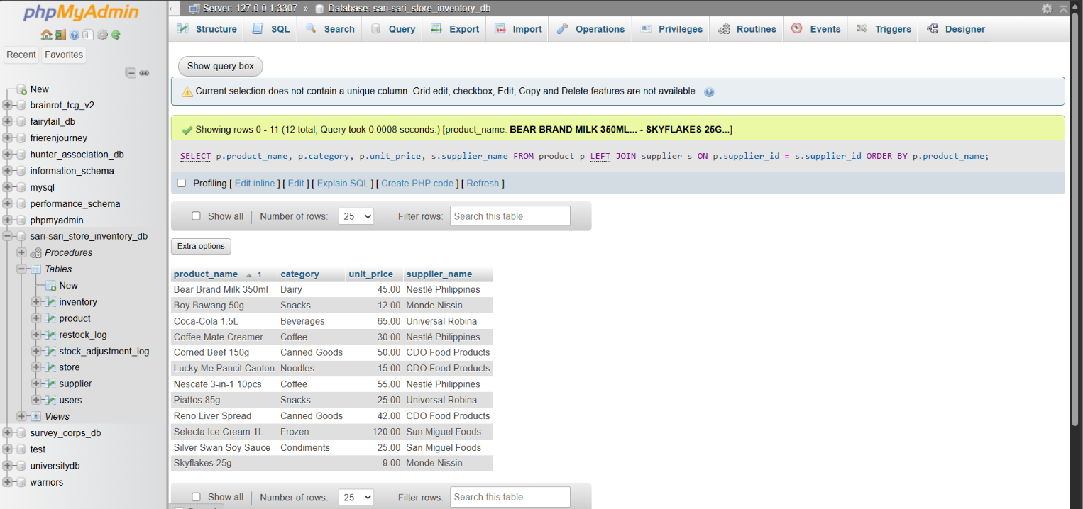
Usage: Used in the Products page and admin panel to display which supplier each item comes from, making ordering and restocking easier.

- Aggregate Query
Purpose:
Calculates the total quantity of all products currently available in the store’s inventory.
Functions Used:
- SUM()
- AS (alias)
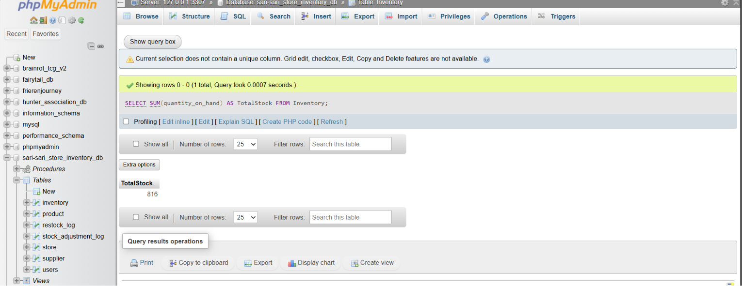
Usage: Runs on the Dashboard to show the overall total stock count in one summary number.

- Subquery
Purpose: Displays all products whose current stock level is below the set reorder level, identifying items that need restocking.
Parent Query: Retrieves product names from the Product table.
Child Query: Retrieves all product_id values where the available stock is less than the required reorder level from the Inventory table.
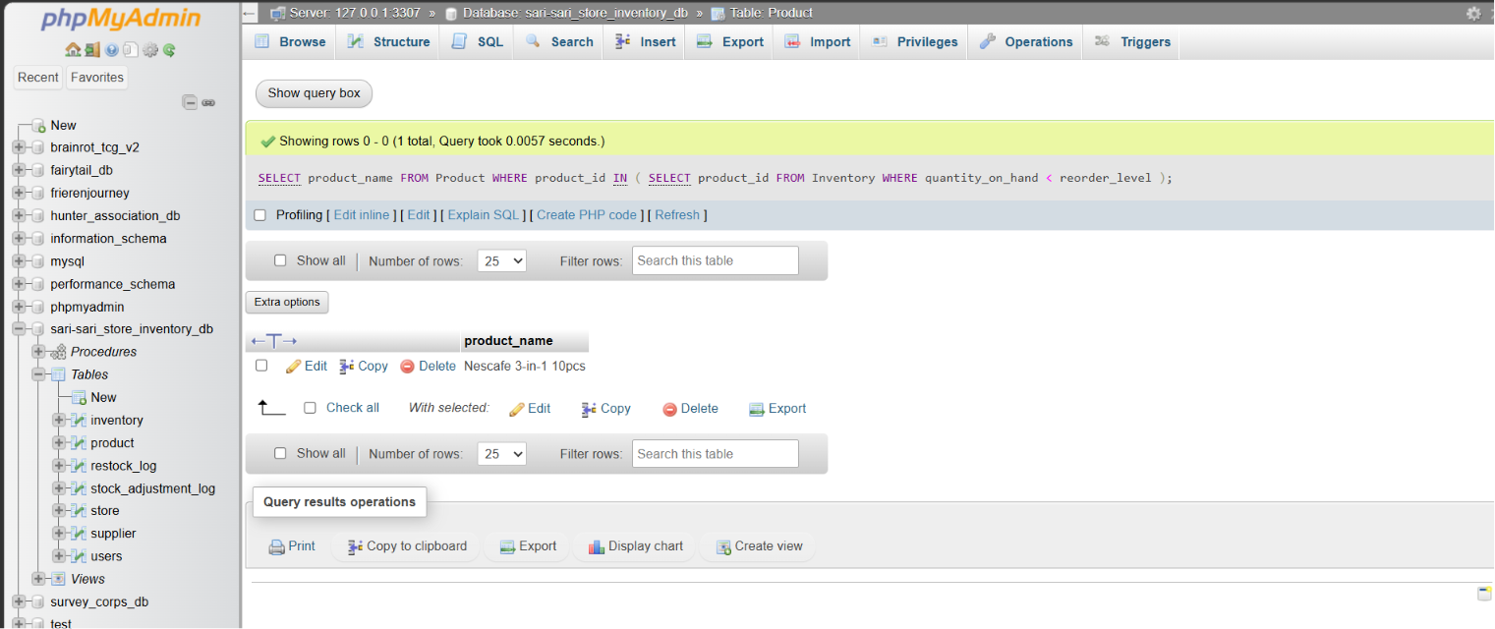
Usage: Powers the Low Stock Report page, automatically showing items that need to be restocked.

Final Project | Section 6 – System Screenshots | DBSYS 1

Main Dashboard
The Dashboard provides the administrator with an overview of the inventory system. It displays important information such as the total number of products, stores, suppliers, and low-stock items. It also shows recent restocking activities and the products with the highest inventory value, allowing the administrator to monitor the overall status of the system efficiently.

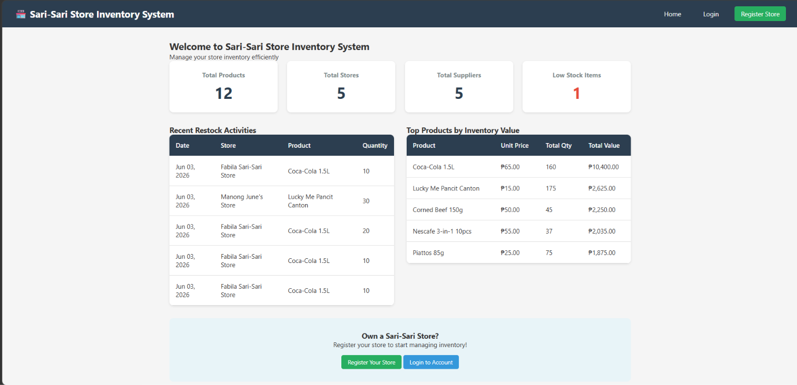

System Admin
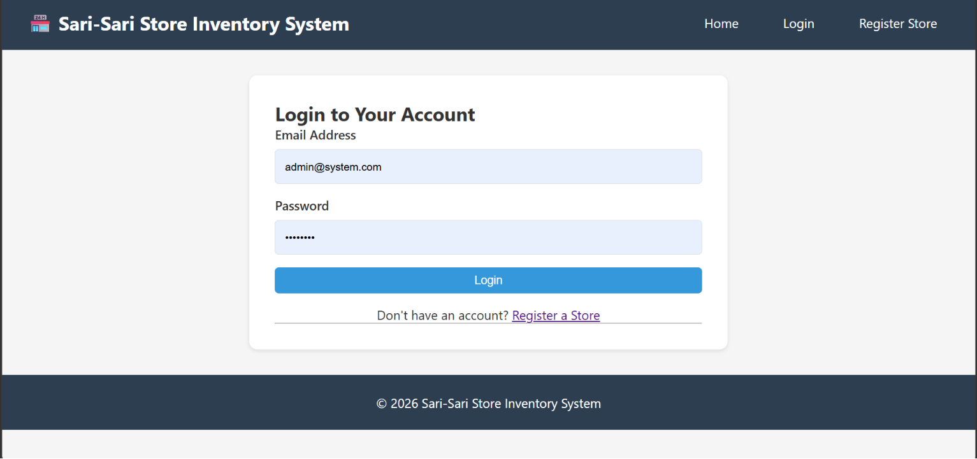
Log in Page
The Login Page allows authorized users to securely access the system by entering their email address and password. This ensures that only registered administrators can manage inventory records and system data.

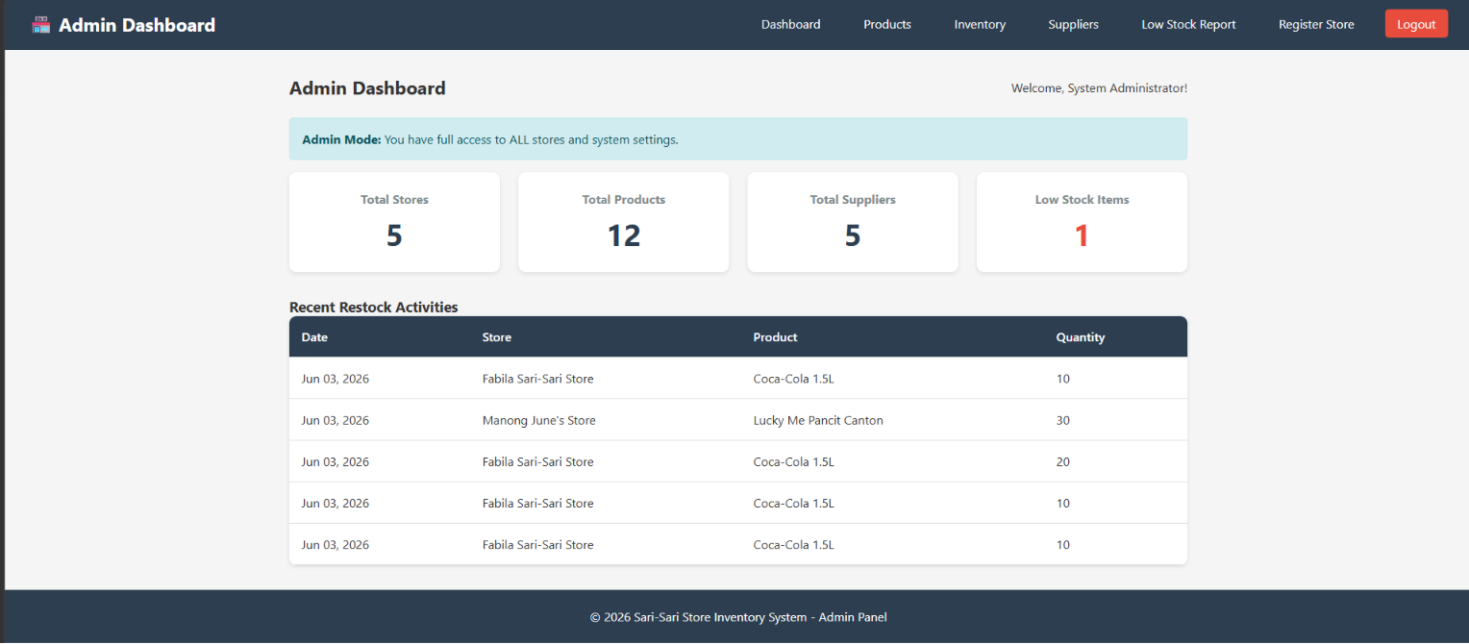
System Admin Dashboard
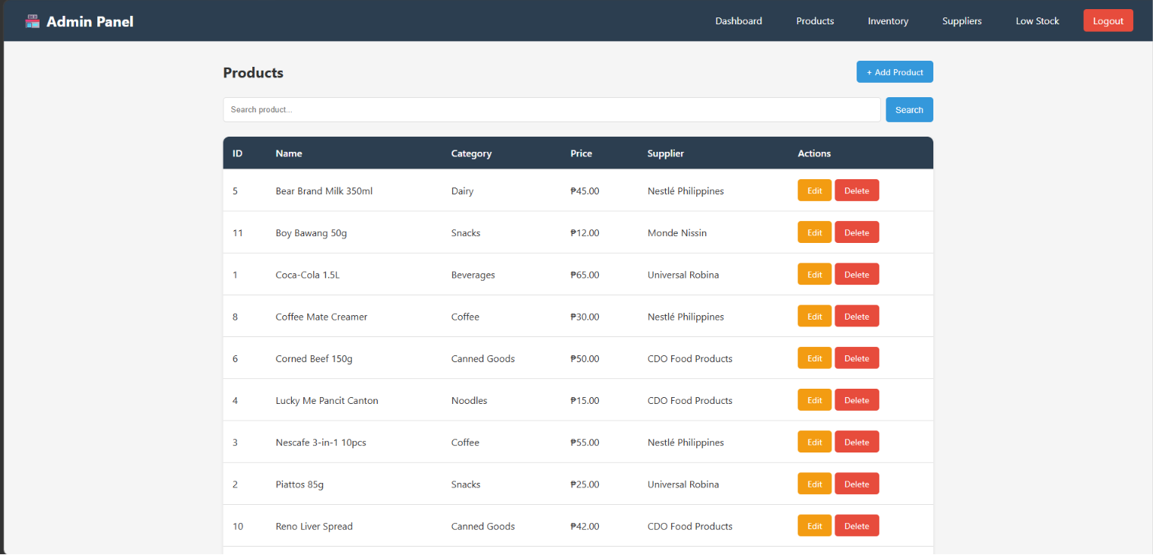
Products
The Products Page displays all registered products along with their category, price, and supplier. It also provides functions to search, add, edit, and delete products, making product management faster and more organized.

Product Management
- My Products: Full list of items with category, price, current stock, reorder level, and status
- Add/Edit/Delete Products: Input details like name, category, price, weight, supplier
- Search/Filter: Quickly find products in the list

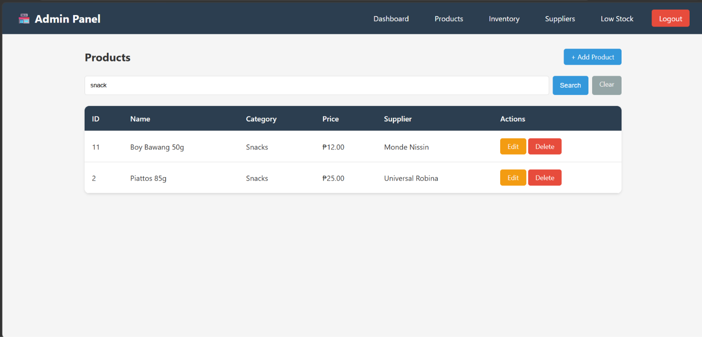
Search through category

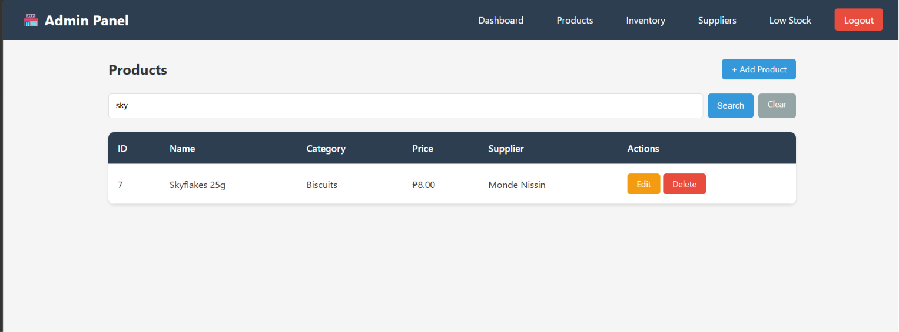
Search through product name
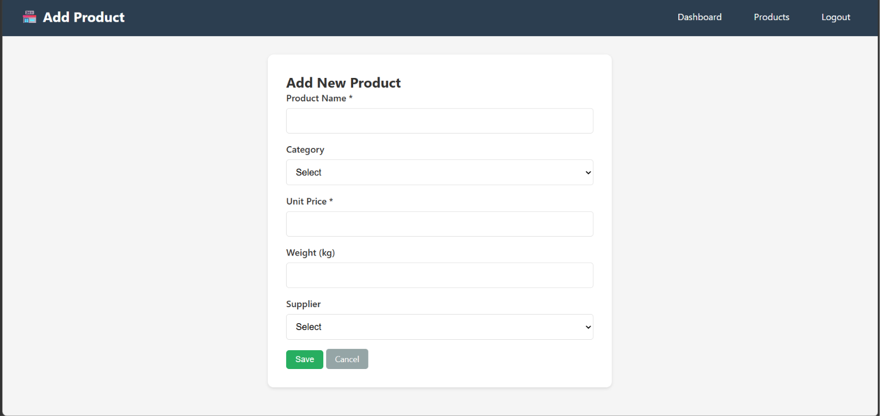
Add New Product (Only System Admin can add product)
The Add Product Page allows the administrator to register a new product by entering its details, including the product name, category, unit price, weight, and supplier. Once submitted, the product is automatically added to the inventory database.

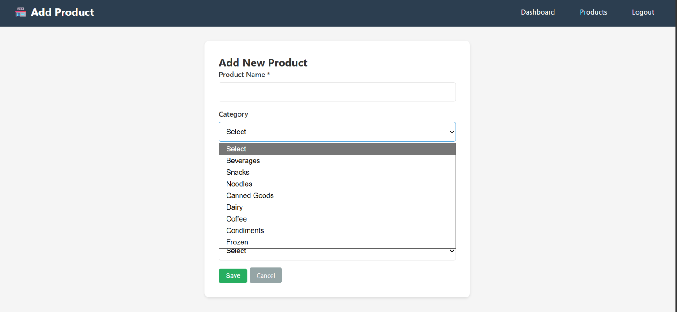
Can select category
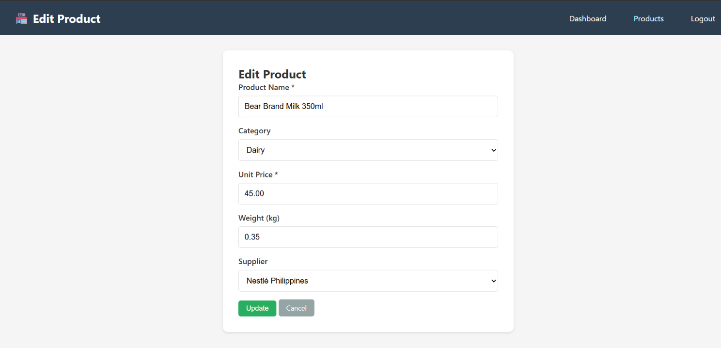
Edit Product(name, category, unit price… etc)
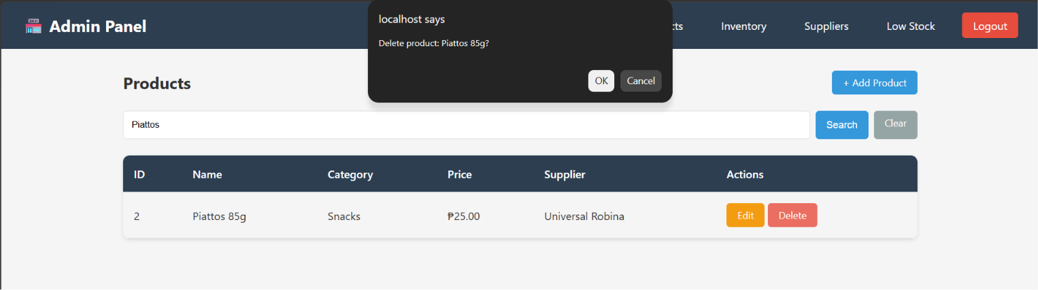
Delete Products(Only System Admin can delete products)

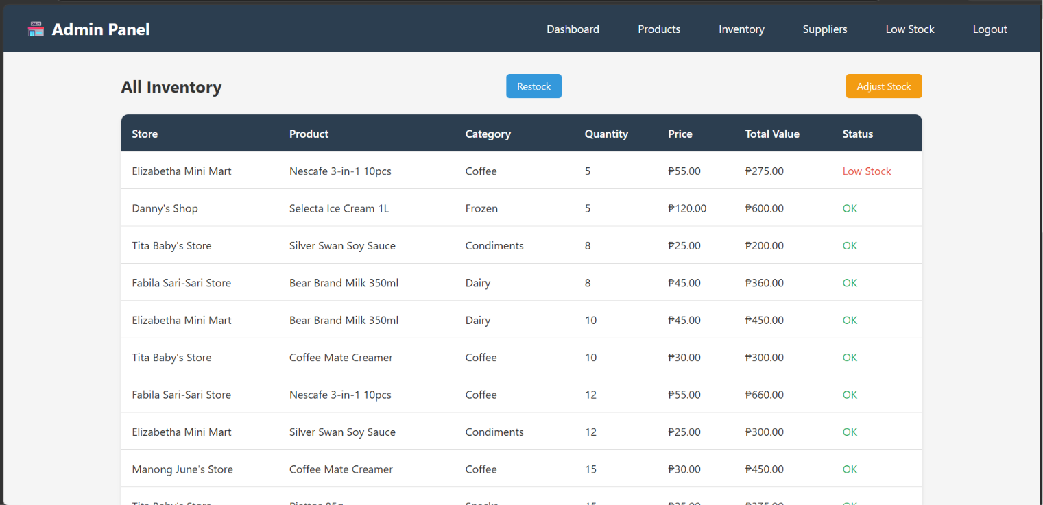
All Inventory (All the stores inventory)
The Inventory Page displays the current stock of all products from different stores. It shows the available quantity, price, total inventory value, and stock status, helping the administrator monitor inventory levels accurately.


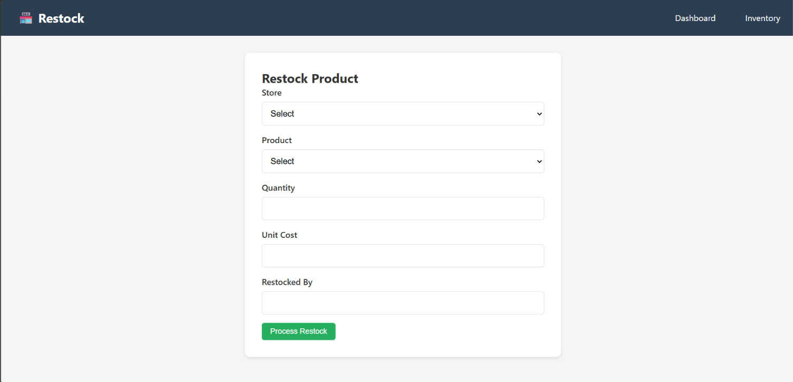
Restock Product (Can select stores)
The Restock Page enables the administrator to replenish inventory by selecting a store and product, entering the quantity, unit cost, and restocked-by information. The system automatically updates the product quantity after the transaction.

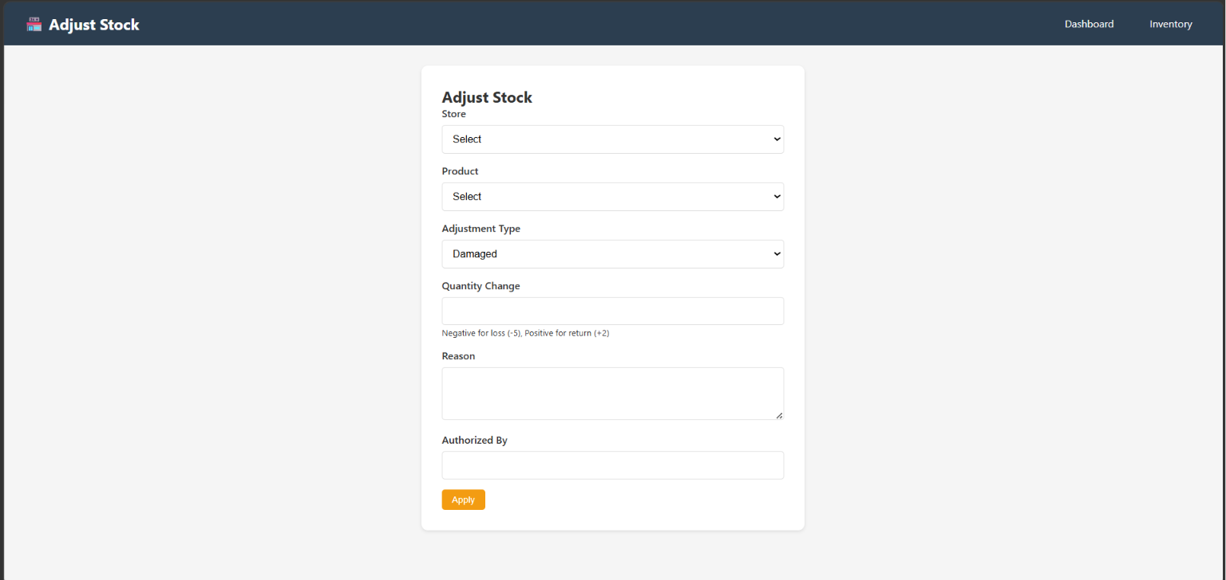
Adjust Stock
The Adjust Stock Page allows the administrator to modify inventory quantities due to damaged, expired, or missing products. Each adjustment requires a reason and authorization to maintain accurate inventory records.

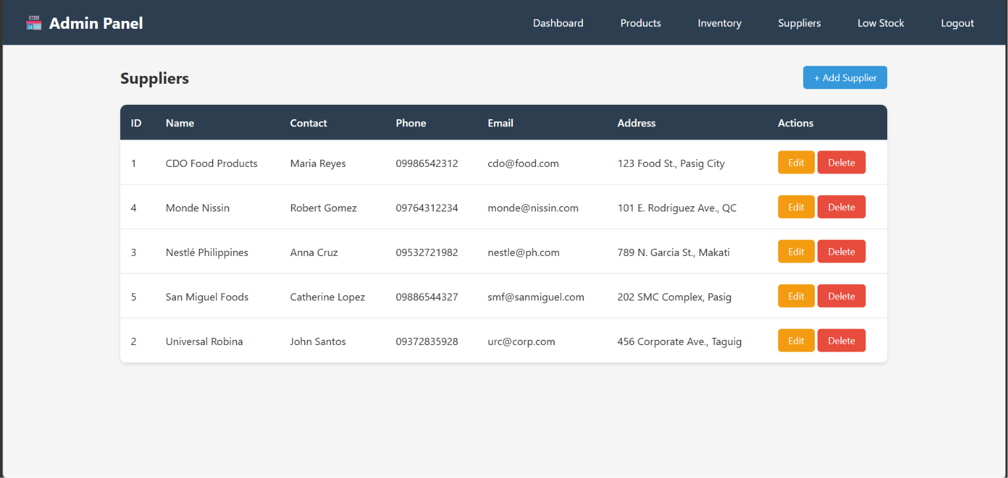
Suppliers
The Suppliers Page contains the list of suppliers and their contact information. Administrators can add, edit, or delete supplier records to keep supplier information updated.
Supplier Management
- Add supplier records with name, contact, phone, email, and address
- Link products to their suppliers for easier ordering

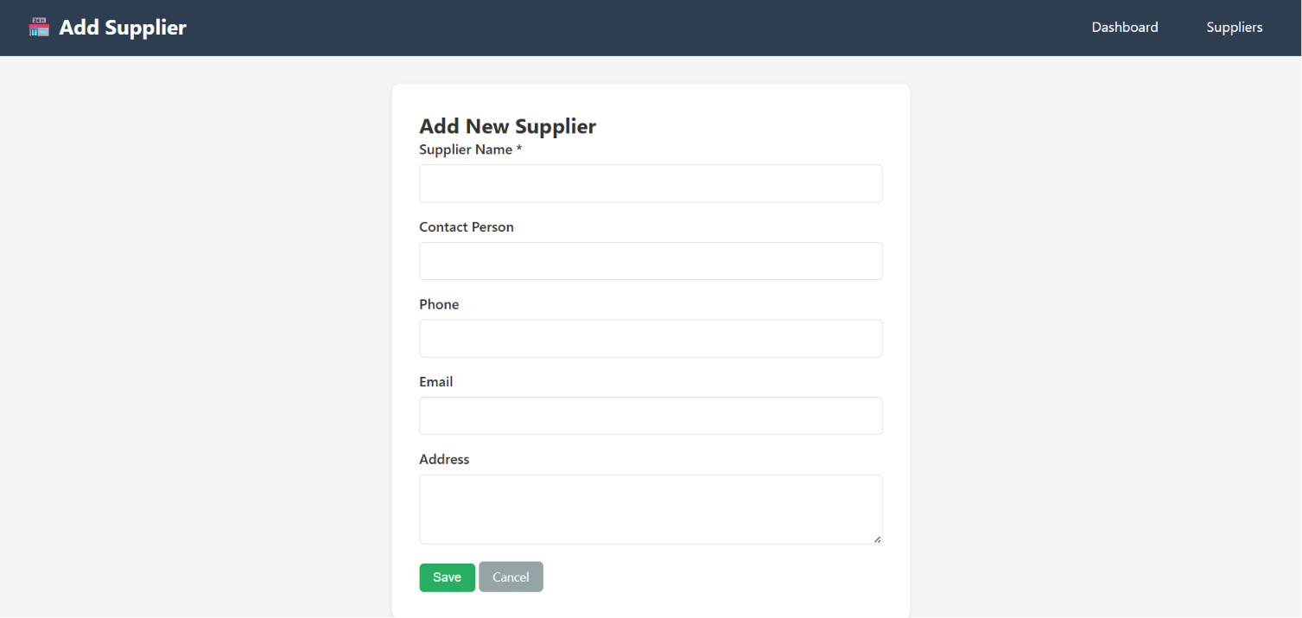
Add Supplier

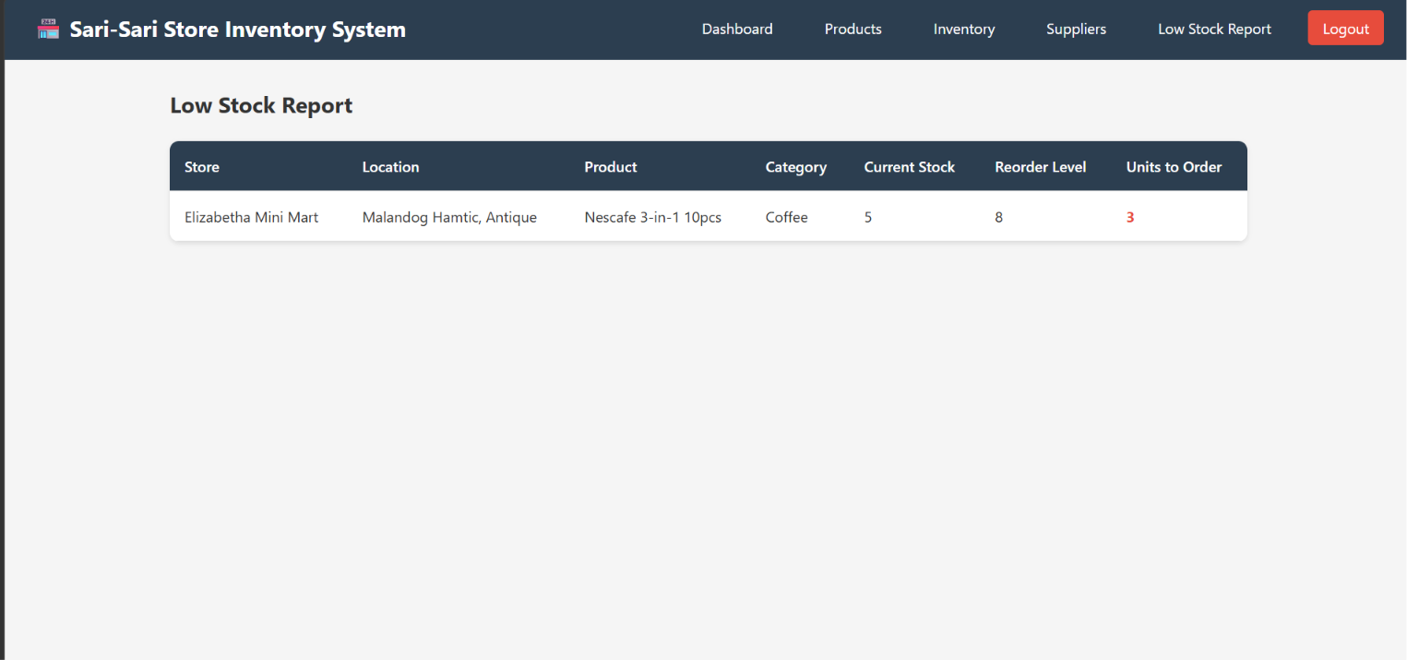
Low stock Report
The Low Stock Report Page displays products that have reached or fallen below their reorder level. This report helps administrators identify items that need immediate restocking to avoid inventory shortages.

Store Owner
Example : Fabila Store
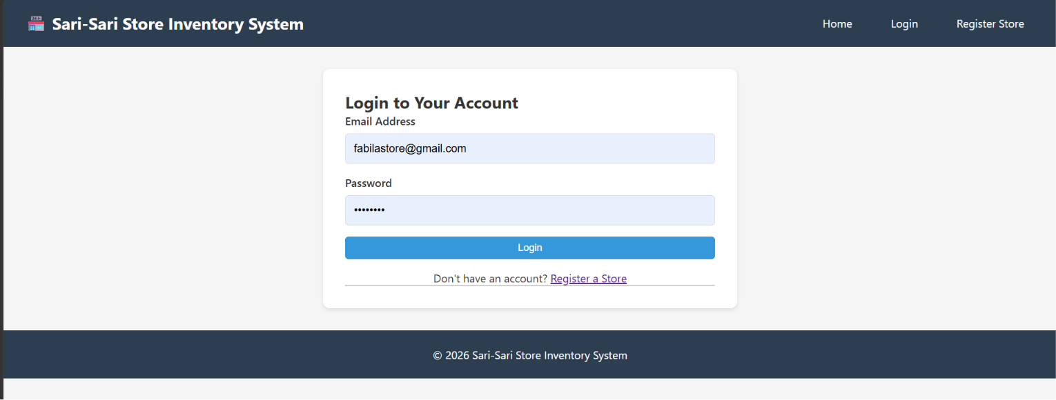
Log in

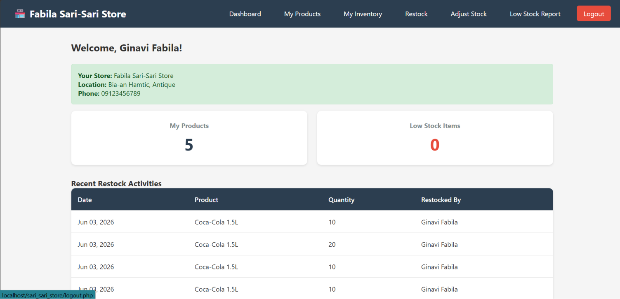
Dashboard
- Welcome screen showing store details (name, location, contact)
- Quick summary: Total products and Low stock count
- Recent restock history log

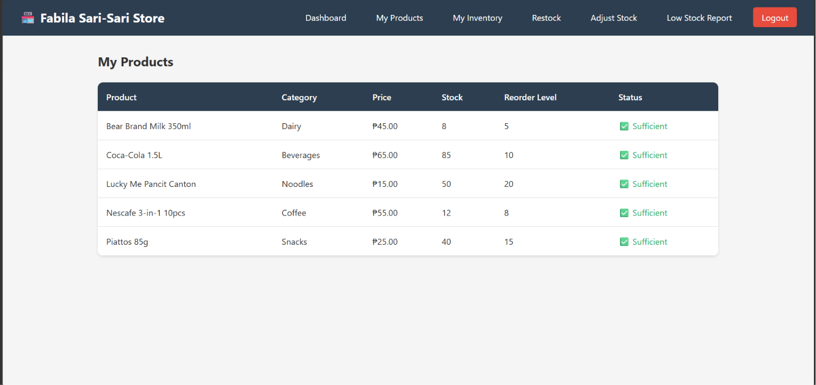
Products
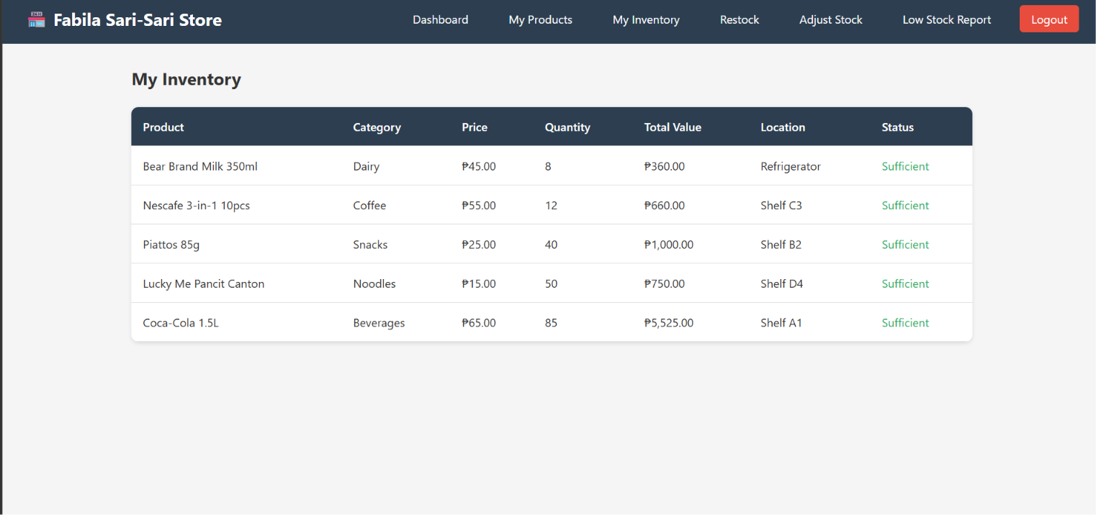
Inventory
Inventory Tracking
- My Inventory: Shows quantity, total value, storage location, and status for every item
- Restock: Add new stock, record cost, and log who processed the restock
- Adjust Stock: Correct inventory for losses, damage, or returns (negative = loss, positive = return)
- Low Stock Report: Automatically flags items below their set reorder level

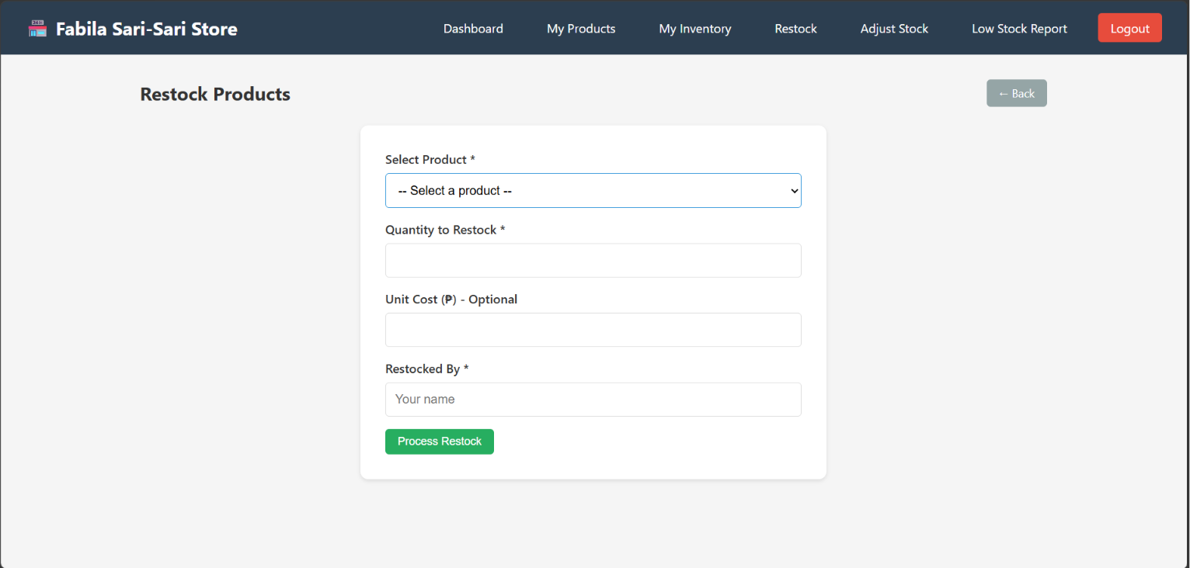
Restock Products
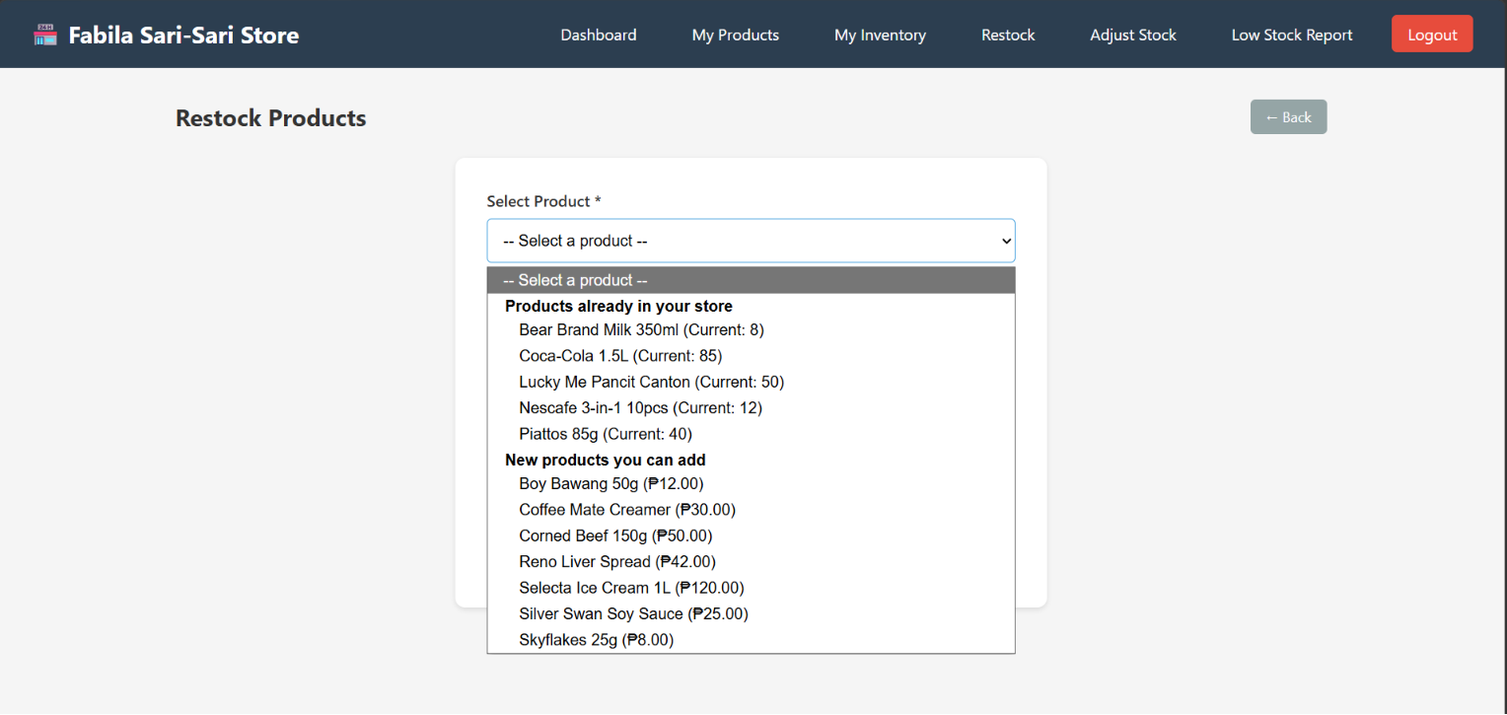
Restock Product: Selecting product (can also add new product)
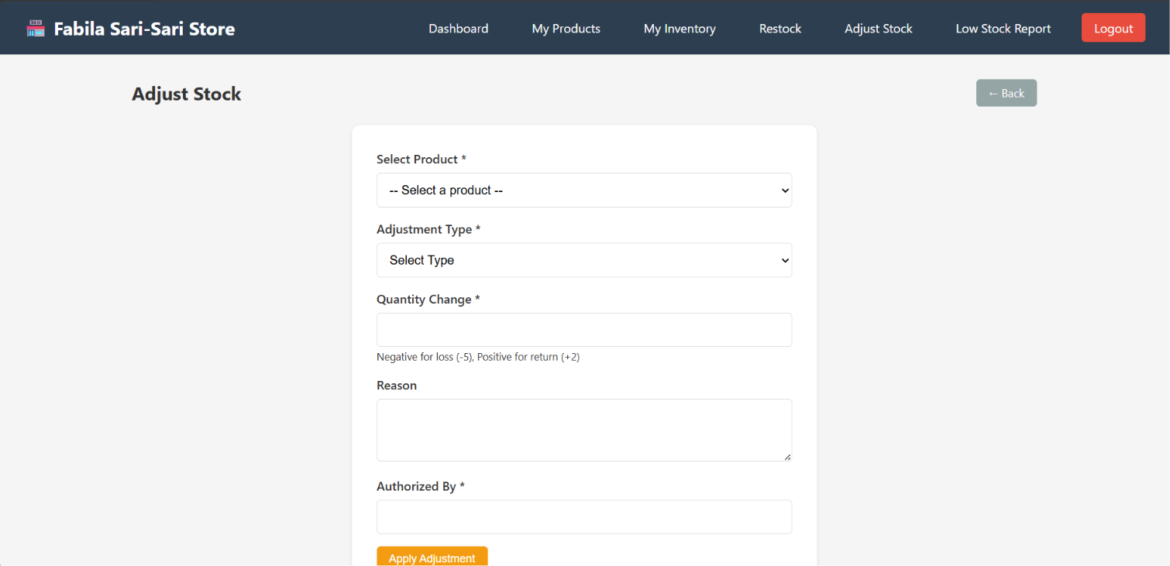
Adjust Stock
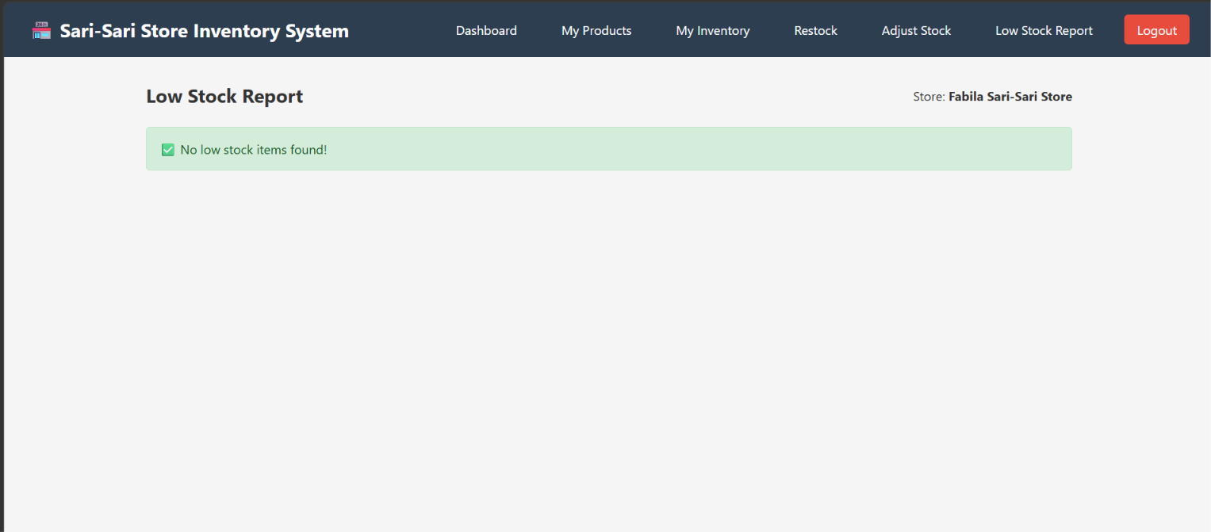
Low stock Report

Register Sari-Sari Store
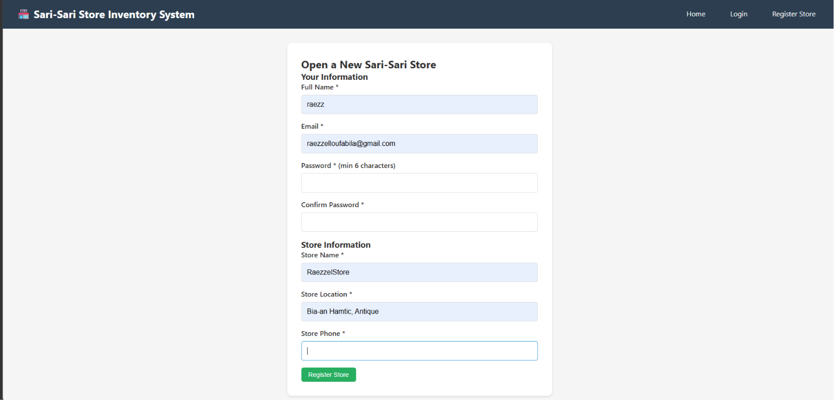

Final Project |  | Section 7 – Individual Contribution Summary | DBSYS 1

1. Raezzel Lou Fabila
Served as the lead developer of the system and was primarily responsible for building the core functionality of the application. Developed all backend PHP scripts required for the system, including user authentication, CRUD operations, inventory processing, supplier management, restocking transactions, and stock adjustment functions. Designed and implemented the user interface using HTML, CSS, and JavaScript to ensure a user-friendly and responsive experience. Established and maintained the database connection, integrated all system components, and ensured smooth communication between the frontend, backend, and database layers. Also participated in debugging, troubleshooting, and optimizing the overall performance of the system.

2. Darleen Joy Esteves
Handled the database design and architecture of the project. Created the Entity-Relationship Diagram (ERD) and carefully analyzed the system requirements to identify the necessary entities, attributes, and relationships. Defined all database tables, fields, data types, primary keys, foreign keys, and constraints to maintain data accuracy and consistency. Implemented the database structure in MySQL and verified that relationships and cardinalities were correctly established. Conducted database testing and validation to ensure data integrity, eliminate redundancy, and improve query efficiency throughout the development process.

3. Jann Mhareoul Abancio
Led the testing and quality assurance phase of the project. Performed comprehensive testing on all major modules, including login, inventory management, supplier management, restocking, and stock adjustment features. Verified that calculations, validations, filtering functions, and user restrictions operated correctly under different scenarios. Identified bugs, system errors, and inconsistencies during testing and documented them for correction. Assisted in verifying implemented fixes through repeated testing and ensured that the final system met the functional requirements and performed reliably before deployment and presentation.
4. Elizabeth Satumbaga
Managed the preparation and organization of the project documentation and presentation materials. Assisted in the planning and development phase of the system by collaborating with Raezzel Lou Fabila in identifying project requirements, organizing system features, and discussing the overall workflow and functionality of the application. Developed the complete project write-up, including the system overview, database documentation, data dictionary, SQL query explanations, diagrams, testing results, and other required sections. Ensured that all documentation followed the prescribed format and academic requirements. Reviewed and organized project files, screenshots, tables, and supporting materials to maintain consistency and clarity throughout the report. Additionally, prepared presentation slides, speaker notes, and supporting documents used during the final project defense and presentation, helping ensure that the project's objectives, design, and implementation were clearly communicated to the audience.

